### Use cases

#### Main use case:

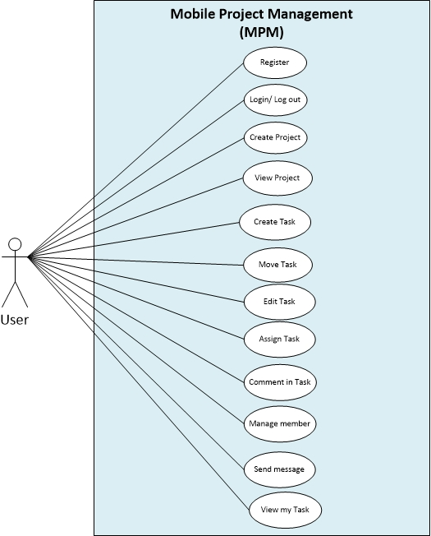

Figure C-III-6-1: Main use case

#### Functional specifications

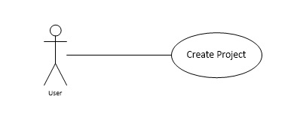

Figure C-III-6-2: Create Project

|  |  |
| --- | --- |
| **Use Case ID** | **0001** |
| **Use Case Name** | **1-Create Project** |
| Date | 6/1/2013 |
| Author | SonLA |
| Brief Description | The application will be make a name to the list for uses to manage their project |
| Actors | Users |
| System | Mobile Project Management |
| Preconditions | User has already logged in the system |
| Post-conditions | The application will be displayed name of project on project’ screen. |
| Flow of Events: Create Project | |  |  |  |  |  | | --- | --- | --- | --- | --- | | Step | Actor Input | System Response |  |  | | 1 | Touch “Add project” button | Dialog box “Add project ” appear |  |  | | 2 | Enter the project name |  |  |  | |  | Touch “Create” button | Display project name on project ‘screen | |
| Exception | |  |  |  |  |  | | --- | --- | --- | --- | --- | | Step | Actor Input | System Response |  |  | | 1 | Not enter the project name |  |  |  | | 2 | Touch “Create” button | “Create” button is invisible |  |  | |

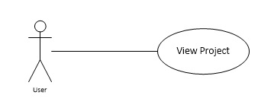

|  |  |
| --- | --- |
| **Use Case ID** | **0002** |
| **Use Case Name** | **2-View Project** |
| Date | 6/1/2013 |
| Author | SonLA |
| Brief Description | This function allows users view an existing project that was created before. |
| Actors | Users |
| Preconditions | Access in application and touch on a existing project |
| Post-conditions | display stateboard and tasks on stateboard’ screen |
| Flow of Events: View Project | |  |  |  |  |  | | --- | --- | --- | --- | --- | | Step | Actor Input | System Response |  |  | | 1 | Touch one of the list project | Display stateboard and tasks in project |  |  | |

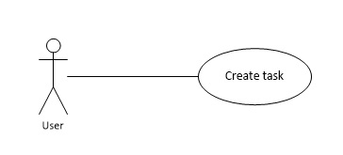

|  |  |
| --- | --- |
| **Use Case ID** | **0003** |
| **Use Case Name** | **3-Create Task** |
| Date | 6/1/2013 |
| Author | SonLA |
| Brief Description | The application will create task in project |
| Actors | Users |
| System | Mobile Project Management |
| Preconditions | Project has already created |
| Post-conditions | The application will be displayed task on stateboard |
| Flow of Events : Create Task | |  |  |  |  |  | | --- | --- | --- | --- | --- | | Step | Actor Input | System Response |  |  | | 1 | Touch “Add Task” button | “Add Task ” screen appear |  |  | | 2 | Enter the task name |  |  |  | | 3 | Enter the description |  | | 4 | Choose start date | DatePicker UI appear | | 5 | Choose due date | DatePicker UI appear | | 6 | Touch “Create” button | Task is created and displayed on stateboard | |
| Exception | |  |  |  |  |  | | --- | --- | --- | --- | --- | | Step | Actor Input | System Response |  |  | | 1 | Not enter the task name | Warning text display |  |  | | 2 |  | “Create” button is invisible |  |  | |

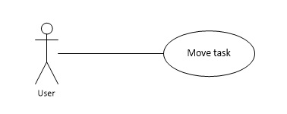

|  |  |
| --- | --- |
| **Use Case ID** | **0004** |
| **Use Case Name** | **4 – Move task** |
| Date | 6/1/2013 |
| Author | SonLA |
| Brief Description | This function allows users move tasks between stateboards |
| Actors | Users |
| Preconditions | Task has created before |
| Post-conditions | Task is moved to a new stateboard |
| Flow of Events: Move task | |  |  |  |  |  | | --- | --- | --- | --- | --- | | Step | Actor Input | System Response |  |  | | 1 | Touch and hold a task at least 1 second | Task has been selected light up |  |  | | 2 | Drag and drop task to a new stateboard | Task has been moved to a new stateboad | |

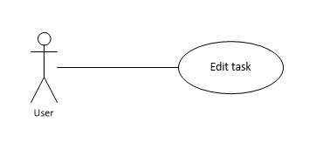

|  |  |
| --- | --- |
| **Use Case ID** | **0005** |
| **Use Case Name** | **5 – Edit task** |
| Date | 6/1/2013 |
| Author | SonLA |
| Brief Description | This function allows users edit an existing task on project |
| Actors | Users |
| Preconditions | Task has created before |
| Post-conditions | Task has updated new infomation |
| Flow of Events: Edit task | |  |  |  |  |  | | --- | --- | --- | --- | --- | | Step | Actor Input | System Response |  |  | | 1 | Touch a task on stateboard | “Edit Task” screen appear |  |  | | 2 | Change the task information |  | | 3 | Touch button Save | The new information of task is update | |
| Exception | |  |  |  |  |  |  | | --- | --- | --- | --- | --- | --- | | Step | Actor Input | System Response | |  |  | | 1 | Make the task name blank | | Warning text display |  |  | | 2 |  | | “Save” button is invisible |  |  | |

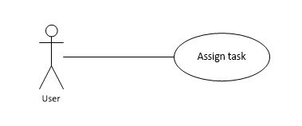

|  |  |
| --- | --- |
| **Use Case ID** | **0006** |
| **Use Case Name** | **6 – Assign Task** |
| Date | 6/1/2013 |
| Author | SonLA |
| Brief Description | This function allows users assign a task to member of project |
| Actors | Users |
| Preconditions | Task has created before |
| Post-conditions | Task is assign to member |
| Flow of Events: Assign Task | |  |  |  |  |  | | --- | --- | --- | --- | --- | | Step | Actor Input | System Response |  |  | | 1 | Touch a task on stateboard | “Edit Task” screen appear |  |  | | 2 | Touch button “Assign to” | “Assign task” screen appear | | 3 | Choose members from member list to assign |  | | 4 | Touch Assign button | “Assign task” screen close | |

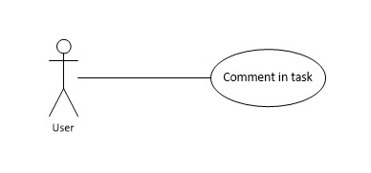

|  |  |
| --- | --- |
| **Use Case ID** | **0007** |
| **Use Case Name** | **7 – Comment in task** |
| Date | 6/1/2013 |
| Author | SonLA |
| Brief Description | This function allows users comment in a task |
| Actors | Users |
| Preconditions | Task has created before |
| Post-conditions | Comment will be display on comment board |
| Flow of Events: Comment in task | |  |  |  |  |  | | --- | --- | --- | --- | --- | | Step | Actor Input | System Response |  |  | | 1 | Touch a comment icon on task card | “Comment task” dialog box display |  |  | | 2 | Comment on textbox |  | | 3 | Touch button “Post” | The comment is post to comment board on task card | |

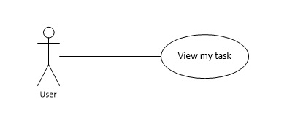

|  |  |
| --- | --- |
| **Use Case ID** | **0008** |
| **Use Case Name** | **8 – View my task** |
| Date | 6/1/2013 |
| Author | SonLA |
| Brief Description | This function allows users view task you have assigned |
| Actors | Users |
| Preconditions | User have assigned at least 1 task |
| Post-conditions | Sort tasks’ user has assigned |
| Flow of Events: View my task | |  |  |  |  |  | | --- | --- | --- | --- | --- | | Step | Actor Input | System Response |  |  | | 1 | Touch member manage icon on project screen | Member mage screen is appear |  |  | | 2 | Touch button “View my task” | The list of task’ user has assigned display | |